

BridgeView Marketing: Coverage Report

Coverage by Category
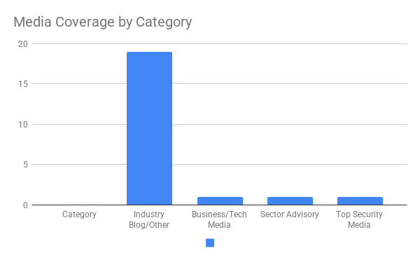

Timeline of Coverage
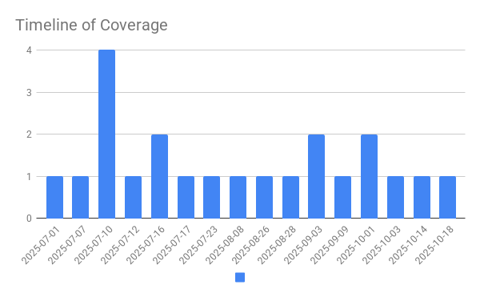

Value Metrics from Placements
Estimated media value incorporates outlet audience (UMV), social promotion reach, and domain authority (MOZ).
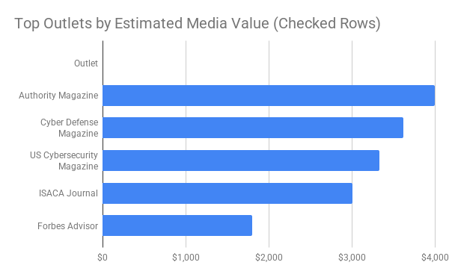

Google Analytics — Acquisition Overview
Window: 2025-10-09 to 2025-10-23
Total sessions: 178
Top channels:
• Direct — 170 sessions
• Organic Social — 4 sessions
• Unassigned — 4 sessions

Sessions by Default Channel Group
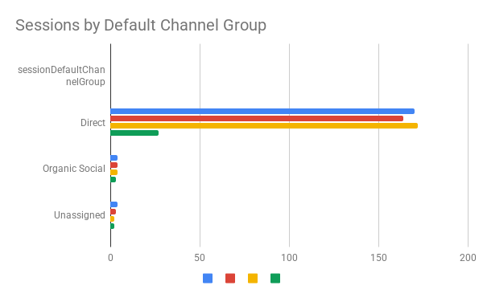
Color key: Sessions = Blue, Total Users = Red, New Users = Yellow, Engaged Sessions = Green.

Daily Sessions Timeline
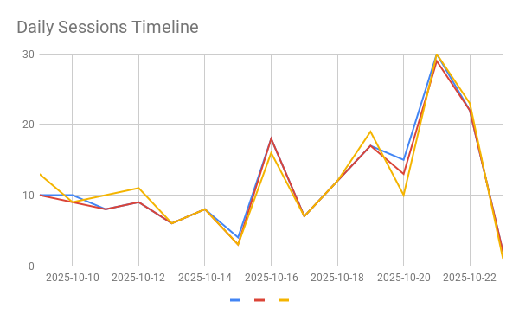

Overlay: GA Sessions vs. Coverage Mentions
Legend: GA Sessions (blue), Coverage Mentions (red)
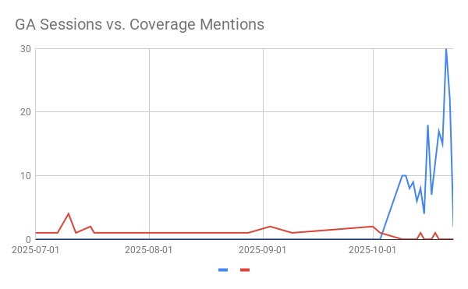

Estimated Reach-Cost of Comparable Paid Media (30-Day Model)
Window: 2024-10-24 to 2025-10-23
Model: $3.00 per active hit per day × 365 days from publish date
Cumulative 30-day value: $4,701

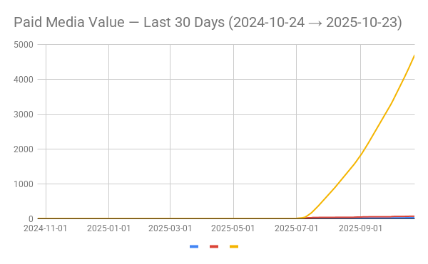

Assumptions: Each press hit remains “active” for 365 days after publish; each active hit is valued at $3.00 per day.

Expanded Coverage List
Click on any press hit title below to go directly to the publication's coverage.

Authority Magazine (2025-10-18)
Cyber Defense: Greg Sullivan of CIOSO Global On The 5 Things Every American Business Leader Should Do To Shield Themselves From A Cyberattack

Forbes Advisor (2025-10-14)
What Is DNS Failure? (And How To Fix It)

Cyber Defense Magazine
[2 BACKLINKS] (2025-10-01)
Mastering Multi-Cloud Security

US Cybersecurity Magazine
[1 BACKLINK] (2025-10-01)
Rethinking Data Governance and Security in the AI Era

ISACA Journal (2025-10-03)
Securing Legacy OT Systems in the Modern Threat Environment

CSO (2025-09-09)
71% of CISOs hit with third-party security incident this year

ITSecurity Wire (X post) (2025-09-03)
Greg Sullivan, Founding partner of CIOSO Global shares why newcomers to cybersecurity should build broad skills to meet the needs of these organizations.

ITSecurityWire Podcast (1 minute excerpt -YouTube) (2025-09-03)
CISOs: Broad Skills for Smaller Orgs #podcast #cybercrime #shorts #viralshorts #techtalks #aithreats

ITSecurityWire Podcast (2025-08-26)
Ensuring CISOs Manage Points Where Cybersecurity Meets Business Risk

Dialectica on Reddit (2025-08-28)
Cybersecurity Executive Brief

Dialectica
LinkedIn:
https://www.linkedin.com/posts/dialectica-research_is-ai-the-future-of-cybersecurity-or-its-activity-7359589271822848000-5-82/?utm_source=share&utm_medium=member_desktop&rcm=ACoAACgIleQBde9G2HoMQMUXs_RTeMsaHMb277I
Per Nathalie Reyes:
If you’d like to share it with your network, here’s a suggested caption you can use or adapt as you wish:
I'm proud to have contributed to this discussion on AI and cybersecurity, exploring whether it’s our greatest ally or biggest challenge. Thanks to Dialectica for the opportunity to share my perspective.
#AI #Cybersecurity #Innovation #FutureTech (2025-08-08)
Cybersecurity Executive Brief
Is AI the future of cybersecurity or its biggest threat?

The CyberWire
[1 BACKLINK]
(2025-07-23)
Business Briefing for 07.23.25

kbi media
[2 BACKLINKS] (2025-07-17)
CIOSO Global Founding Partner Greg Sullivan Joins Technology Partners

CyberDefenseWire
[2 BACKLINKS] (2025-07-16)
CIOSO Global Founding Partner Greg Sullivan Joins Technology Partners

Dialectica (2025-07-16)
Challenging the Status Quo in Cyber: Greg Sullivan’s Vision for Smarter AI and Secure Software

Enterprise Security Tech (2025-07-12)
Greg Sullivan Joins Technology Partners to Coach CIOs and CISOs Through High-Stakes Transitions

Journal of Cyber Policy (2025-07-10)
Greg Sullivan Joins Technology Partners to Coach CIOs and CISOs Through High-Stakes Transitions

Kalkine Media (2025-07-10)
CIOSO Global Founding Partner, Greg Sullivan, Joins Technology Partners

Digital IT News
[2 BACKLINKS - 1 to CIOSO, 1 to Technology Partners] (2025-07-10)
Greg Sullivan, Founding Partner of CIOSO Global, Joins Technology Partners

AP NEWS (and 33 other postings)
[3 BACKLINKS] (2025-07-10)
CIOSO Global Founding Partner, Greg Sullivan, Joins Technology Partners

Insight Jam YouTube (2025-07-07)
Best Cybersecurity Use Cases for AI Agents

Solutions Review (2025-07-01)
Key Insights from Insight Jam’s “Fortress AI: Deploying AI Agents for Ironclad Security” Panel

Executive Summary
Search terms: — | Window: Last 14 days
Total unique coverage items: 22
Outlets covered: 22 | Top category: Industry Blog/Other (19)
Coverage dates: 2025-07-01 to 2025-10-18 | Peak: 2025-07-10 (4)
BridgeView Marketing secured broad pickup across key security publications with strong projected earned value (EMV) and ROI.

Key Takeaways for Executives
- Strong penetration in Industry Blog/Other with 19 mentions; presence across authoritative outlets.
- Awareness surge on 2025-07-10 (peak 4 items), indicating message resonance.
- High-value placements projected via EMV modeling that incorporates outlet authority (MOZ) and audience (UMV + social).

